Response Seletion Chatbot for Goal-Oriented Dialogue

Chansu Park
School of Computing
KAIST
Daejeon, South Korea
hhosu107@kaist.ac.kr

line 1: 2nd Given Name Surname
line 2: dept. name of organization (of Affiliation)
line 3: name of organization (of Affiliation)
line 4: City, Country
line 5: email address or ORCID
line 1: 3rd Given Name Surname
line 2: dept. name of organization (of Affiliation)
line 3: name of organization (of Affiliation)
line 4: City, Country
line 5: email address or ORCID
line 1: 4th Given Name Surname
line 2: dept. name of organization (of Affiliation)
line 3: name of organization (of Affiliation)
line 4: City, Country
line 5: email address or ORCID

Abstract—A chatbot is a computer program or an artificial intelligence which conducts a conversation via auditory or textual methods. Many companies now release their own chatbots for various practical purposes including customer service or information acquisition. However, many chatbots fail to recognize the context of the dialogue, similar usage, or sentences including broken grammar, typos or abbreviations. In this paper, the Response Selection Chatbot for Goal-Oriented Dialogue is proposed to overcome the above weaknesses. This model outperforms than the baseline model in terms of the Top 1 accuracy up to 2.5 times.
Keywords—chatbot, context recognition, neural network

Introduction
Machine learning developed many breakthrough results like classifying images, object detection, and so on. Moreover, machine learning is now available for decision making: for instance, AlphaGo developed by Google Deepmind.
In the next step, recent researches have introduced their artificial intelligence which recognizes the context or the goal of the situation. Context recognition is important for AI, since one of the most important aim for developing AI is make them to understand what is needed for humans and answer/react properly. For instance, autonomous driving car accepts the destination where user wants to go and drive automatically, while recognizing the situation on the road in real-time to finish the driving safely and within the appropriate time limit.

Figure 2. Left: Google Assistant successfully recognize exchange rate instead of exchange; Right: WibeeTalk failed to recognize exchange rate.
As a user-friendly product, companies now launched their chatbots to solve customer’s requests. For instance, Google launched Google Assistant that replies for the use input in text or voice. For the specific purpose like asking bank-related works, banks of Korea also introduced their own AI clerks.
To interact with users, chatbots have to satisfy some properties. First, they have to answer similarly for inputs having similar meaning. Second, even for the incomplete sentences with broken grammar, typos or abbreviations, they still have to return the right answer. Third, but not least, they have to recognize the context of the dialogue. However, current chatbots fails often to satisfy the above properties.
Figure 2 shows the comparison between Google Assistant and Wooribank WibeeTalk that how differently replies for the input exchange rate rather than exchange. Google Assistant recognized what user wants to know (the amount in Korea won that corresponds to 100 dollars), while WibeeTalk failed, which violates the first property.

Figure 1. Google Assistant and Wooribank WibeeTalk
The left side of the Figure 3 shows that WibeeTalk failed to recognize the context. The user first asked for the exchange rate of US dollar, and asked “what about the China”, which omitted exchange rate from its input but still wants to know about the exchange rate for the China currency. However it suggested some unrelated results about china money. The right side of the Figure 3 shows that WibeeTalk failed to recognize the similar usage. After the user added 100 in his input, it just stated that the user has to follow the input form. These two examples shows the violation for the third property.

Figure 3. Left: failed to ask exchange rate with omitting words according to the context. Right: failed to add text.
=================== Context ===================
User1: ugh ubuntu wotn read my ipod... i can acess the harddrive
but gtkpod wont recognize it.. :(

User2: Try rhythmbox. rhythmbox reads ipods nicely in breezy
User1: SEjeff, i can put songs on my ipod through rhythmbox?
=================== Correct Answer =============
82: No, but I got gtkpod to work perfectly with my nano and breezy
============== Example of utterances ==============
3: I doubt they would even consider giving support...
12: no
26: I'm not sure then.
41: ok, let that finish first then
67: use /join #kubuntu-de
82: No, but I got gtkpod to work perfectly with my nano and breezy
91: I dont know, you said it was 4yrs old, I thought you may know of the bug off hand.
98: itm must be in options - somewhere
Figure 4. An example dialogue in Ubuntu Dialogue Corpus.
In our research, we suggest a chatbot to overcome weaknesses mentioned above. First, we introduce the properties of our dataset. Next, we introduce the baseline model and our model. Finally, we compare the accuracy of these two models and suggest the future work and applications.
In this paper, section 2 describes the dataset and the baseline model. Section 3 analyzes more complex model and introduces our model. Section 4 shows the accuracy of the answer. Section 5 concludes the results and suggests the future work and possible applications.

Background

Response Selection problem
Response selection problem is a problem that selects the right reaction for the given answer pool. This problem is the minor version of the Response Generation Problem, but we focused on the Response Selection Problem. It is because that generation task has too wide possible response pool which makes us not to expect a proper response in most cases, whereas selection task has restricted response set to select, and thus the higher accuracy to solve this problem can be achieved easier than the generation problem.
In the case of chatbot, there are two individuals: human and the chatbot. Human wants to know about what he or she need via chatbot. Thus we started to implement chatbot which can take care about the two-person goal-oriented conversation as an input. To overcome the proposed weaknesses that we proposed on the section 1, we need some examples containing wrong grammar, typos, and even needless emoji. For the specific needs, we took care about expertized terminology from task-specific domain. The purpose of this chatbot is to solve the response selection problem.

Ubuntu Dialogue Corpus [1]
For the response selection problem, there is an appropriate dataset to construct the model for goal-oriented conversation, which is Ubuntu Dialogue Corpus. This dataset is a collection of chatting logs from Ubuntu-related chat rooms. Each dialogue contains an Ubuntu-related problem from Ubuntu users in that chat room.
Each chatting log in the Ubuntu Dialogue Corpus has expertized knowledge about Ubuntu, and users talk to each other with broken grammar, typos or emoji. Thus this dataset is feasible for our research.
Here is the detailed specification for the problem with Ubuntu Dialogue Corpus.
- Task: select the next utterance from given candidate set. Candidate set contains 100 options, where the only 1 option is the correct answer.
- Evaluation criteria: the accuracy of the results, measured from Top n selected answers in 100. n = 1, 2, 5, 10, and 50.

Baseline Model
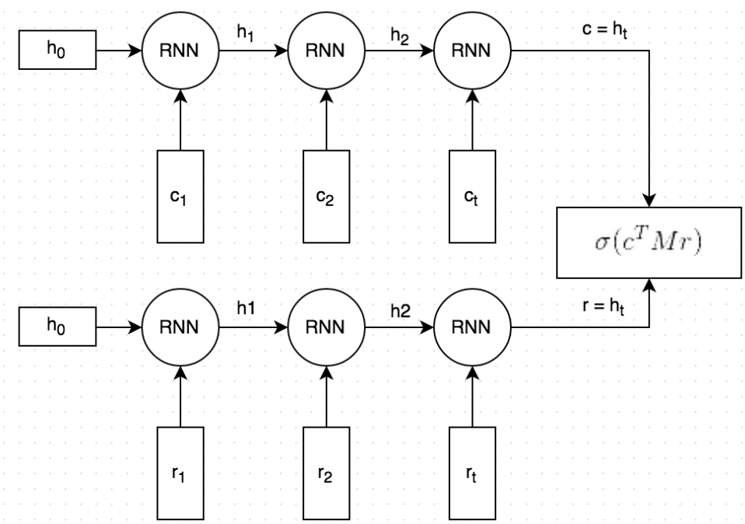
In the same paper Ubuntu dialogue corpus, they introduced their baseline model to decide the right result. It takes conversations and responses as a vector of words, and the recurrent neural network captures the meaning of each sentences. Then it predicts the response and compares to the actual response by taking dot product. As the dot product gets bigger, the prediction goes similar to the answer. Finally, it converts that value to the probability. Then it sorts the probability for each candidates to get the top n answers.
conversation
response
probability
Softmax
100 responses
Avoid combining SI Use either SI (MKS) or CGS as primary units. (SI units are encouraged.) English units may be used as secondary template is used to format your paper and style the text. All margins, column widths, line spaces, and text fonts are prescribed; please do not alter them. You may note peculiarities. For example, the head margin in this template measures proportionately more than is customary. This measurement and others are deliberate, using specifications that anticipate your paper as one part of the entire proceedings, and not as an independent document. Please do not revise any of the current designations.

Proposed Models
Before you begin to format your paper, first write and save the content as a separate text file. Complete all content and organizational editing before formatting. Please note sections A-D below for more information on proofreading, spelling and grammar.
Keep your text and graphic files separate until after the text has been formatted and styled. Do not use hard tabs, and limit use of hard returns to only one return at the end of a paragraph. Do not add any kind of pagination anywhere in the paper. Do not number text heads-the template will do that for you.

Abbreviations and Acronyms
Define abbreviations and acronyms the first time they are used in the text, even after they have been defined in the abstract. Abbreviations such as IEEE, SI, MKS, CGS, sc, dc, and rms do not have to be defined. Do not use abbreviations in the title or heads unless they are unavoidable.

Units
- Use either SI (MKS) or CGS as primary units. (SI units are encouraged.) English units may be used as secondary units (in parentheses). An exception would be the use of English units as identifiers in trade, such as “3.5-inch disk drive”.
- Avoid combining SI and CGS units, such as current in amperes and magnetic field in oersteds. This often leads to confusion because equations do not balance dimensionally. If you must use mixed units, clearly state the units for each quantity that you use in an equation.
- Do not mix complete spellings and abbreviations of units: “Wb/m2” or “webers per square meter”, not “webers/m2”. Spell out units when they appear in text: “. . . a few henries”, not “. . . a few H”.
- Use a zero before decimal points: “0.25”, not “.25”. Use “cm3”, not “cc”. (bullet list)

Equations
The equations are an exception to the prescribed specifications of this template. You will need to determine whether or not your equation should be typed using either the Times New Roman or the Symbol font (please no other font). To create multileveled equations, it may be necessary to treat the equation as a graphic and insert it into the text after your paper is styled.
Number equations consecutively. Equation numbers, within parentheses, are to position flush right, as in (1), using a right tab stop. To make your equations more compact, you may use the solidus ( / ), the exp function, or appropriate exponents. Italicize Roman symbols for quantities and variables, but not Greek symbols. Use a long dash rather than a hyphen for a minus sign. Punctuate equations with commas or periods when they are part of a sentence, as in:
a  b    
Note that the equation is centered using a center tab stop. Be sure that the symbols in your equation have been defined before or immediately following the equation. Use “(1)”, not “Eq. (1)” or “equation (1)”, except at the beginning of a sentence: “Equation (1) is . . .”

Some Common Mistakes
- The word “data” is plural, not singular.
- The subscript for the permeability of vacuum μ₀, and other common scientific constants, is zero with subscript formatting, not a lowercase letter “o”.
- In American English, commas, semicolons, periods, question and exclamation marks are located within quotation marks only when a complete thought or name is cited, such as a title or full quotation. When quotation marks are used, instead of a bold or italic typeface, to highlight a word or phrase, punctuation should appear outside of the quotation marks. A parenthetical phrase or statement at the end of a sentence is punctuated outside of the closing parenthesis (like this). (A parenthetical sentence is punctuated within the parentheses.)
- A graph within a graph is an “inset”, not an “insert”. The word alternatively is preferred to the word “alternately” (unless you really mean something that alternates).
- Do not use the word “essentially” to mean “approximately” or “effectively”.
- In your paper title, if the words “that uses” can accurately replace the word “using”, capitalize the “u”; if not, keep using lower-cased.
- Be aware of the different meanings of the homophones “affect” and “effect”, “complement” and “compliment”, “discreet” and “discrete”, “principal” and “principle”.
- Do not confuse “imply” and “infer”.
- The prefix “non” is not a word; it should be joined to the word it modifies, usually without a hyphen.
- There is no period after the “et” in the Latin abbreviation “et al.”.
- The abbreviation “i.e.” means “that is”, and the abbreviation “e.g.” means “for example”.
An excellent style manual for science writers is [7].

Using the Template
After the text edit has been completed, the paper is ready for the template. Duplicate the template file by using the Save As command, and use the naming convention prescribed by your conference for the name of your paper. In this newly created file, highlight all of the contents and import your prepared text file. You are now ready to style your paper; use the scroll down window on the left of the MS Word Formatting toolbar.

Authors and Affiliations
The template is designed for, but not limited to, six authors. A minimum of one author is required for all conference articles. Author names should be listed starting from left to right and then moving down to the next line. This is the author sequence that will be used in future citations and by indexing services. Names should not be listed in columns nor group by affiliation. Please keep your affiliations as succinct as possible (for example, do not differentiate among departments of the same organization).

For papers with more than six authors: Add author names horizontally, moving to a third row if needed for more than 8 authors.

For papers with less than six authors: To change the default, adjust the template as follows.

Selection: Highlight all author and affiliation lines.

Change number of columns: Select the Columns icon from the MS Word Standard toolbar and then select the correct number of columns from the selection palette.

Deletion: Delete the author and affiliation lines for the extra authors.

Identify the Headings
Headings, or heads, are organizational devices that guide the reader through your paper. There are two types: component heads and text heads.
Component heads identify the different components of your paper and are not topically subordinate to each other. Examples include Acknowledgments and References and, for these, the correct style to use is “Heading 5”. Use “figure caption” for your Figure captions, and “table head” for your table title. Run-in heads, such as “Abstract”, will require you to apply a style (in this case, italic) in addition to the style provided by the drop down menu to differentiate the head from the text.
Text heads organize the topics on a relational, hierarchical basis. For example, the paper title is the primary text head because all subsequent material relates and elaborates on this one topic. If there are two or more sub-topics, the next level head (uppercase Roman numerals) should be used and, conversely, if there are not at least two sub-topics, then no subheads should be introduced. Styles named “Heading 1”, “Heading 2”, “Heading 3”, and “Heading 4” are prescribed.

Figures and Tables

Positioning Figures and Tables: Place figures and tables at the top and bottom of columns. Avoid placing them in the middle of columns. Large figures and tables may span across both columns. Figure captions should be below the figures; table heads should appear above the tables. Insert figures and tables after they are cited in the text. Use the abbreviation “Fig. 1”, even at the beginning of a sentence.
- Table Type Styles
Table Head | Table Column Head
Table Head | Table column subhead | Subhead | Subhead
copy | More table copyª
- Sample of a Table footnote. (Table footnote)
- Example of a figure caption. (figure caption)
Figure Labels: Use 8 point Times New Roman for Figure labels. Use words rather than symbols or abbreviations when writing Figure axis labels to avoid confusing the reader. As an example, write the quantity “Magnetization”, or “Magnetization, M”, not just “M”. If including units in the label, present them within parentheses. Do not label axes only with units. In the example, write “Magnetization (A/m)” or “Magnetization {A[m(1)]}”, not just “A/m”. Do not label axes with a ratio of quantities and units. For example, write “Temperature (K)”, not “Temperature/K”.

Acknowledgment (Heading 5)
The preferred spelling of the word “acknowledgment” in America is without an “e” after the “g”. Avoid the stilted expression “one of us (R. B. G.) thanks ...”. Instead, try “R. B. G. thanks...”. Put sponsor acknowledgments in the unnumbered footnote on the first page.

References
The template will number citations consecutively within brackets [1]. The sentence punctuation follows the bracket [2]. Refer simply to the reference number, as in [3]—do not use “Ref. [3]” or “reference [3]” except at the beginning of a sentence: “Reference [3] was the first ...”
Number footnotes separately in superscripts. Place the actual footnote at the bottom of the column in which it was cited. Do not put footnotes in the abstract or reference list. Use letters for table footnotes.
Unless there are six authors or more give all authors’ names; do not use “et al.”. Papers that have not been published, even if they have been submitted for publication, should be cited as “unpublished” [4]. Papers that have been accepted for publication should be cited as “in press” [5]. Capitalize only the first word in a paper title, except for proper nouns and element symbols.
For papers published in translation journals, please give the English citation first, followed by the original foreign-language citation [6].

- The Ubuntu Dialogue Corpus: A Large Dataset for Research in Unstructured Multi-Turn Dialogue Systems. arXiv:1506.08909v3 [cs.CL]
We suggest that you use a text box to insert a graphic (which is ideally a 300 dpi TIFF or EPS file, with all fonts embedded) because, in an MSW document, this method is somewhat more stable than directly inserting a picture.
To have non-visible rules on your frame, use the MSWord “Format” pull-down menu, select Text Box > Colors and Lines to choose No Fill and No Line.
- J. Clerk Maxwell, A Treatise on Electricity and Magnetism, 3rd ed., vol. 2. Oxford: Clarendon, 1892, pp.68–73.
- I. S. Jacobs and C. P. Bean, “Fine particles, thin films and exchange anisotropy,” in Magnetism, vol. III, G. T. Rado and H. Suhl, Eds. New York: Academic, 1963, pp. 271–350.
- K. Elissa, “Title of paper if known,” unpublished.
- R. Nicole, “Title of paper with only first word capitalized,” J. Name Stand. Abbrev., in press.
- Y. Yorozu, M. Hirano, K. Oka, and Y. Tagawa, “Electron spectroscopy studies on magneto-optical media and plastic substrate interface,” IEEE Transl. J. Magn. Japan, vol. 2, pp. 740–741, August 1987 [Digests 9th Annual Conf. Magnetics Japan, p. 301, 1982].
- M. Young, The Technical Writer’s Handbook. Mill Valley, CA: University Science, 1989.
IEEE conference templates contain guidance text for composing and formatting conference papers. Please ensure that all template text is removed from your conference paper prior to submission to the conference. Failure to remove template text from your paper may result in your paper not being published.

